ML Major 3

Submitters:
Husain Azaqy: 213382104
Galor Lazar: 325028876

$$\frac{∂}{∂b}L\left(w,b\right)=\frac{∂}{∂b}\left(\frac{1}{m}\sum_{i=1}^{m}{{\left(w^{T}∙x_{i}+b-y_{i}\right)}^{2}}\right)= \frac{1}{m}\sum_{i=1}^{m}{2∙\left(w^{T}∙x_{i}+b-y_{i}\right)}=2b+\frac{2}{m}\sum_{i=1}^{m}{\left(w^{T}∙x_{i}-y_{i}\right)}$$

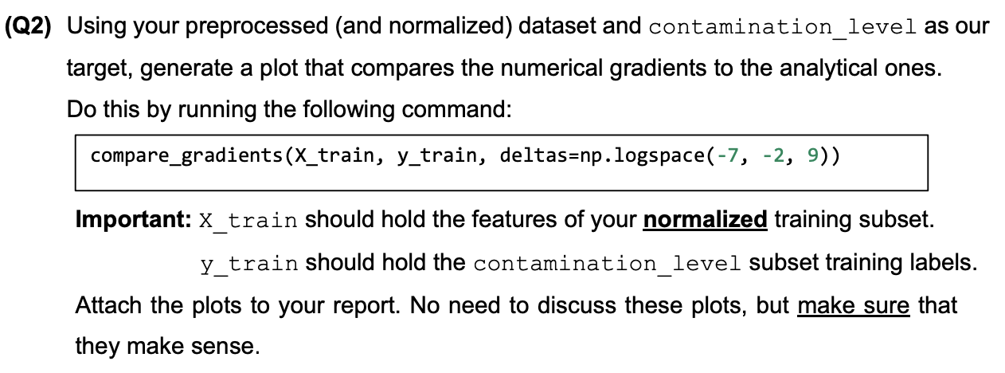

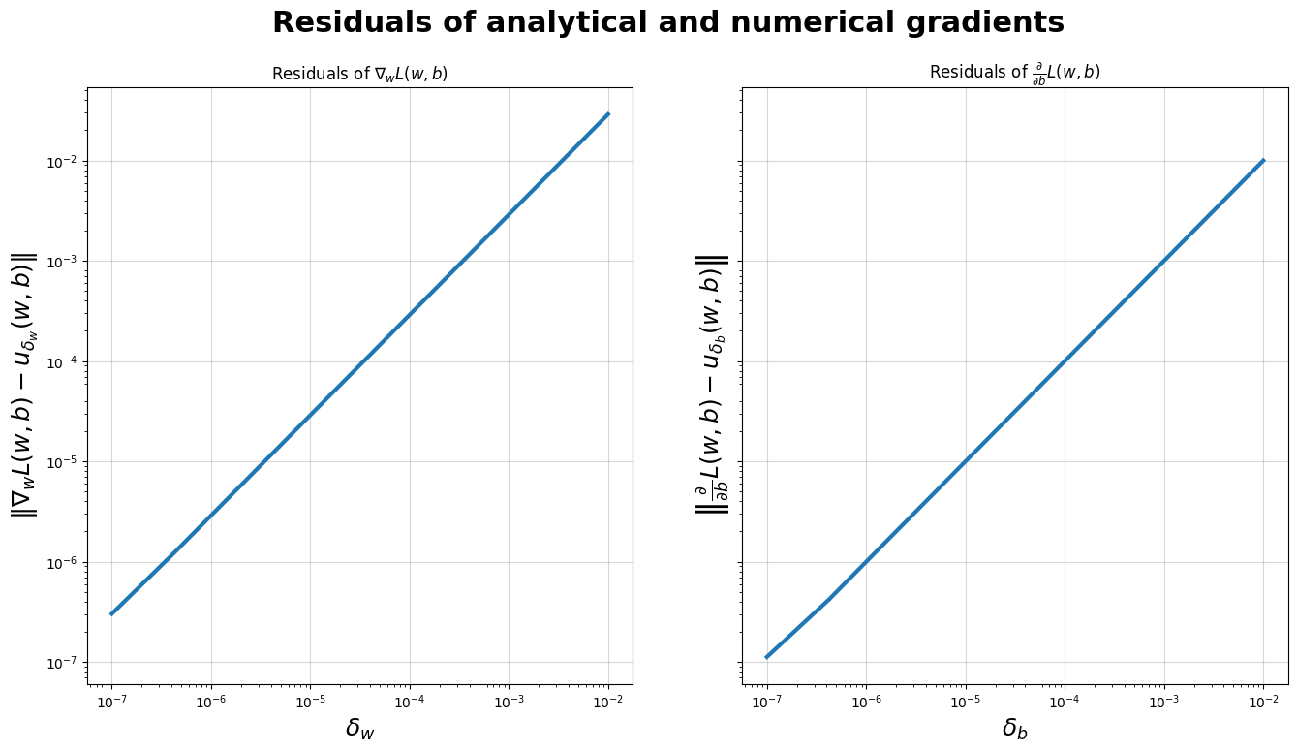

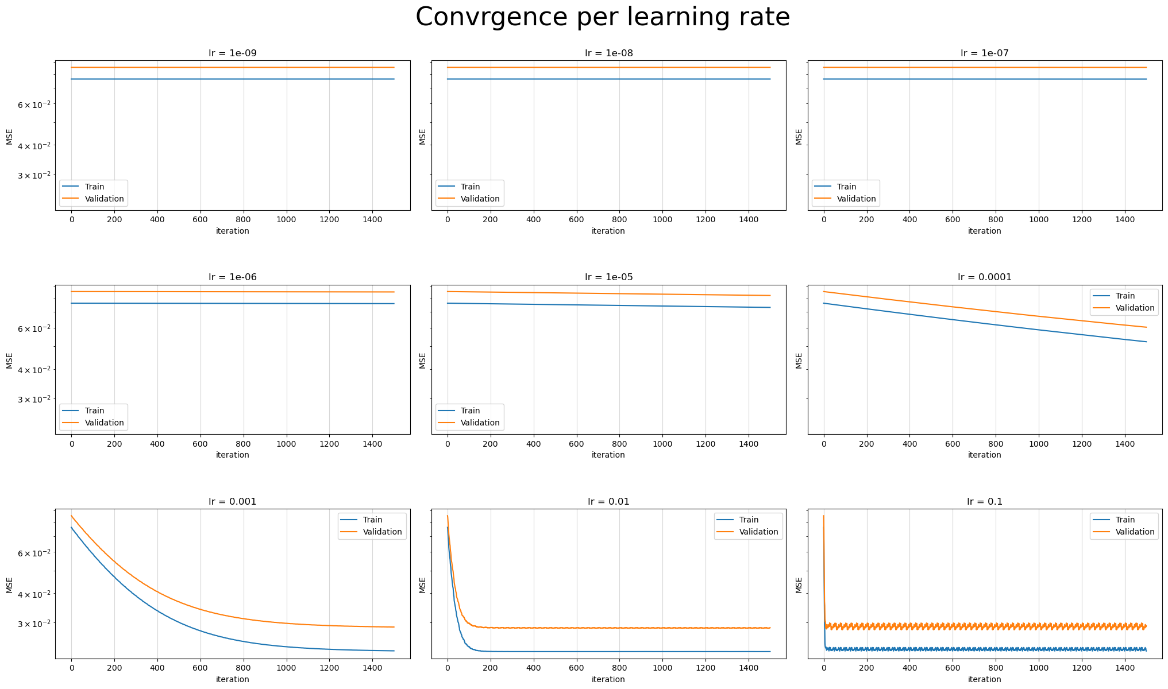
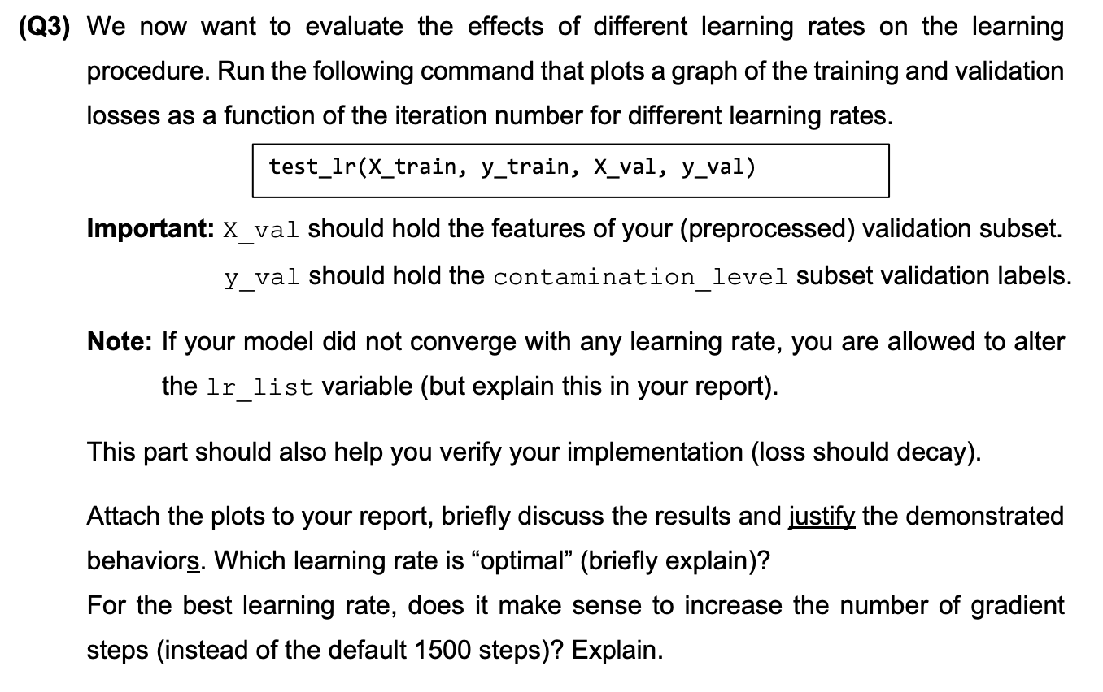

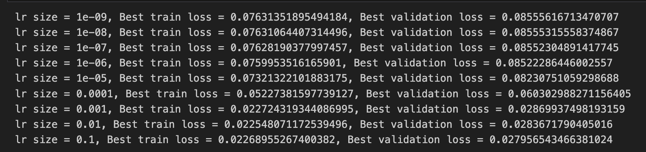
We can see that in cases where the lr<0.0001 the learning is very slow and doesn’t converge. That happens because in these cases the lr in every iteration is too small, so it doesn’t have a significant enough effect on the model accuracy.
So, if we take larger learning rates, we will get better accuracies and better convergence as well as we doing more iterations.
As we can see, the best performance we get is on lr=0.1. Also, in its graph, we can see that it converges even before the first 200 iterations. After those iterations, there are only small “zigzags” that are in almost consistent cycles that don’t get any better than what we got after the first 200 iterations.
By this, we know we can get the best accuracy of the lr=0.1 in a much smaller amount of iterations than 1500 steps.
If so, there is no sense to do a higher amount of 1500 iterations.

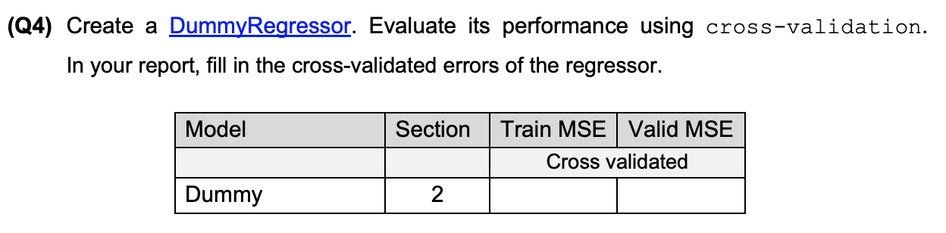
Model | Section | Train MSE | Valid MSE
 |  | Cross validation
Dummy | 2 | -0.06624823283856855 | -0.06655387736460414

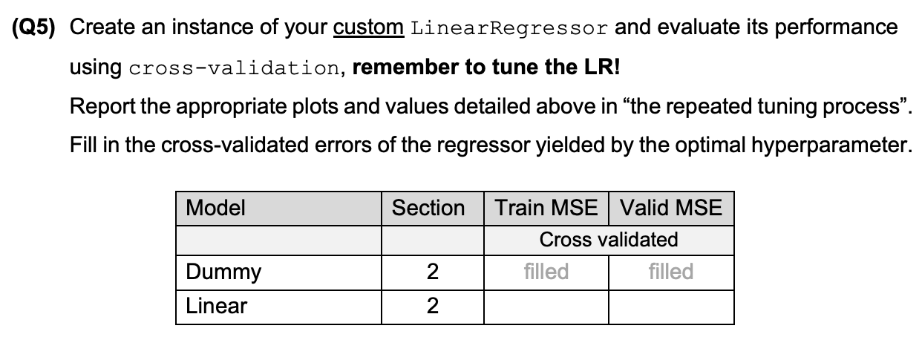
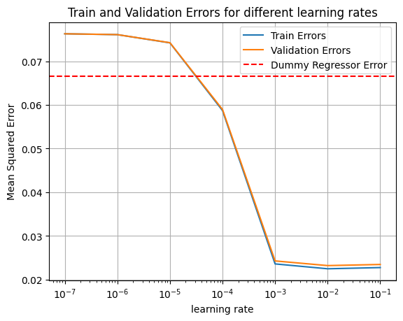
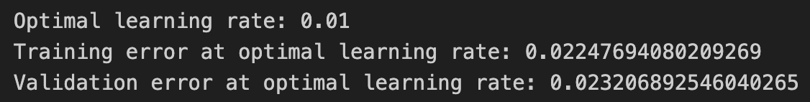
Model | Section | Train MSE | Valid MSE
 |  | Cross validation
Dummy | 2 | -0.06624823283856855 | -0.06655387736460414
Linear | 2 | 0.02247694080209269 | 0.023206892546040265

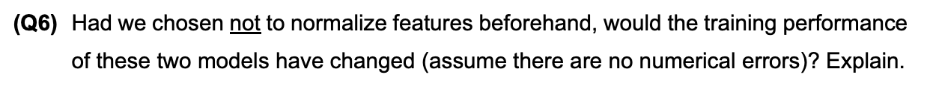
The Dummy model always predicts the average ‘contamination_level’ of the training set. This model doesn’t take into account the features, it only takes the y’ value and returns the average. If so, normalizing the features wouldn't affect the model predictions and performance.
For the Linear model, the model may converge slower with no normalization, and the learned coefficients may be less meaningful or skewed because of the influence of larger in scale features. So it can hurt the model's performance and predictions of new data.
All in all, not normalizing features won’t change the Dummy model performance but may hurt the Linear model performance.

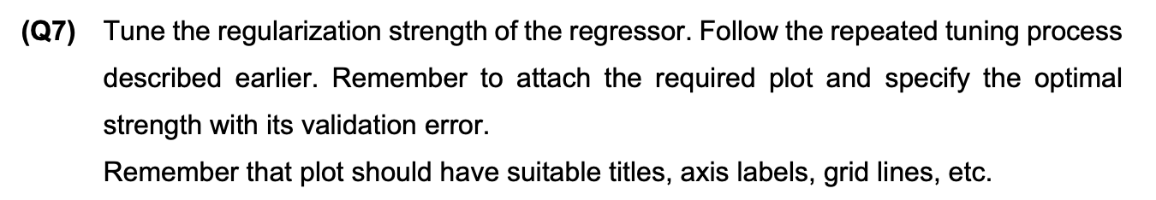
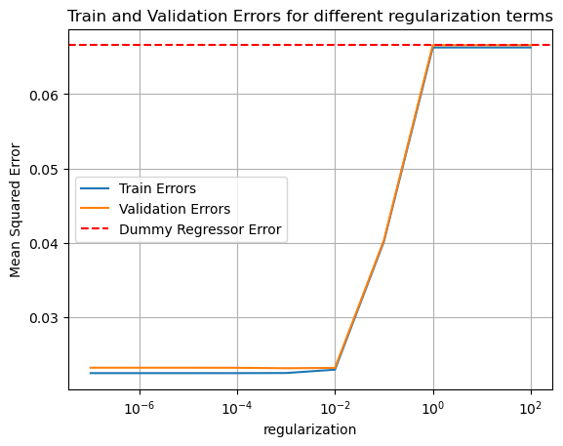
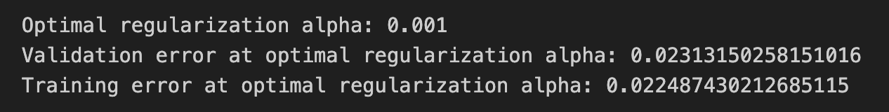

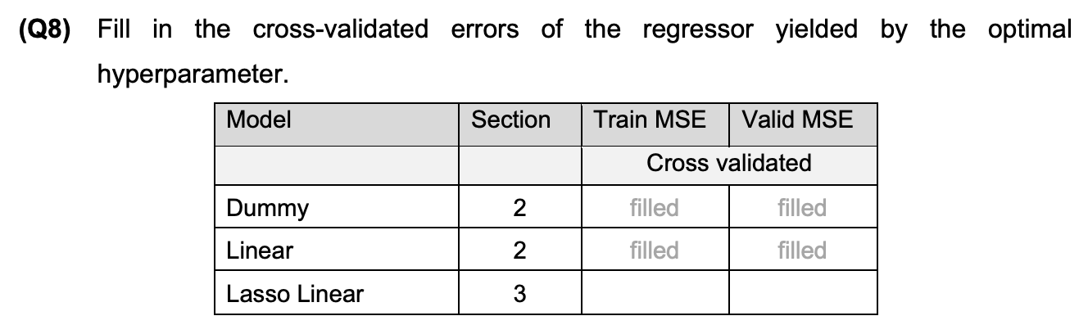
Model | Section | Train MSE | Valid MSE
 |  | Cross validation
Dummy | 2 | -0.06624823283856855 | -0.06655387736460414
Linear | 2 | 0.02247694080209269 | 0.023206892546040265
Lasso Linear | 3 | 0.022487430212685115 | 0.02313150258151016

Feature: PCR_04, Coefficient: 0.19188858316551435
Feature: PCR_02, Coefficient: 0.072140668782269
Feature: PCR_06, Coefficient: 0.04064930398881352
Feature: PCR_10, Coefficient: 0.00947751005415817
Feature: PCR_09, Coefficient: 0.00544732875497806

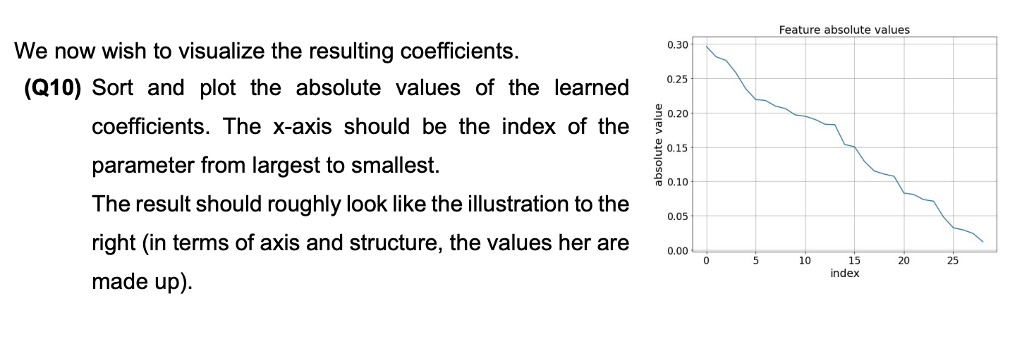
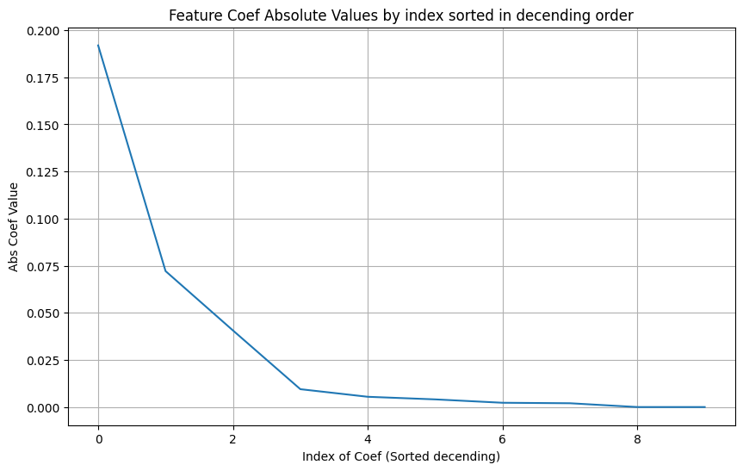
The magnitude of the coefficients is interesting because it indicates the effect of a feature on the final target variable.
Let us remember that the features are normalized. As much as the coefficient of a specific feature is larger (in absolute value) it means that this feature has a larger effect on the target variable. In the same way, a smaller coefficient indicates a weaker influence and correlation.
By checking which feature coefficients are the largest, we can analyze the magnitude of the coefficients and identify which features are most important for the model’s predictions.
Knowing which features have the largest coefficients allows us to focus on the most relevant features. This can be very useful in high-dimensional datasets where many features might be irrelevant.
If the features are not normalized, they may have different scales.
With non-normalized features, since λ is applied equally to all coefficients, the scale of features affects the Lasso l1 regularization.
Larger, less important variables might not have their coefficients reduced to zero due to their scale, while more important small scale features might be shrunk with zero coefficients.
This may happen because Lasso “variable selection “ can be affected by feature scale. As a result, features with larger scales might be under-penalized, and those with smaller scales might be over-penalized. This imbalance can lead to retaining less relevant features and discarding important ones, ultimately skewing the model’s results and hurting its performance.
Regarding the trained lasso model coefficients, like before we expect for large scaled features to have non zero coefficients, and for smaller scaled features to have closer to zero coefficients.
Using the ridge regressor, since it has l2 regularization it tends to shrink coefficients to zero less than the l1 regularization used in the lasso model.
We can argue that the ridge model here is more non_normalization proof here since it tends to zero out less coefficients inherently.

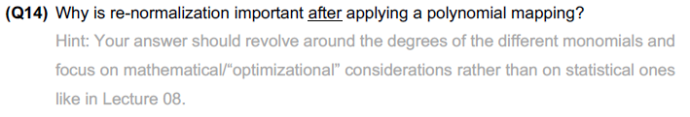
The magnitude of a polynomial feature involves multiple monomials and powers of them, potentially changing the scale of the new polynomial features relative to the original bas features.
We already saw in the lectures that the magnitude of the features can effect learning especially when dealing with gradient descent.

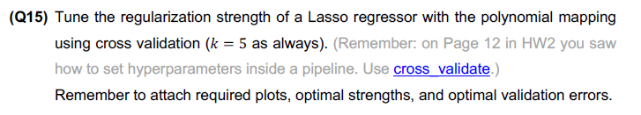
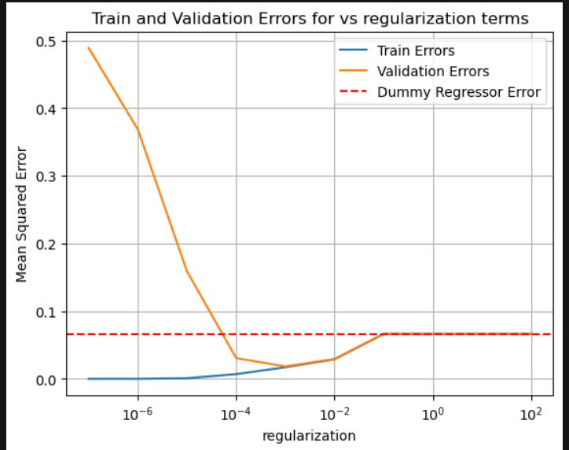
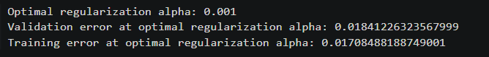

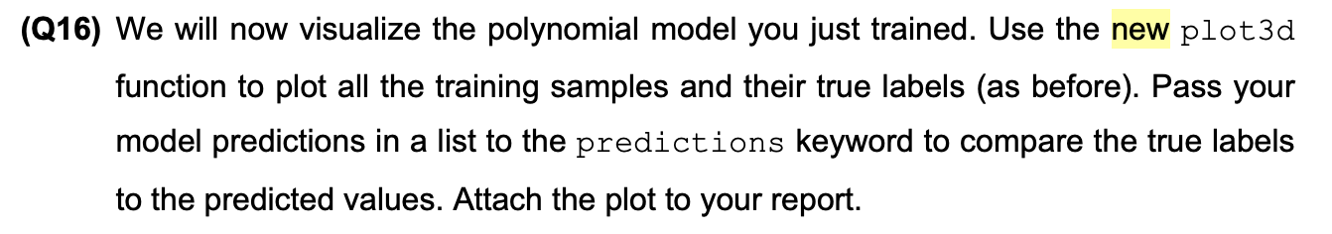
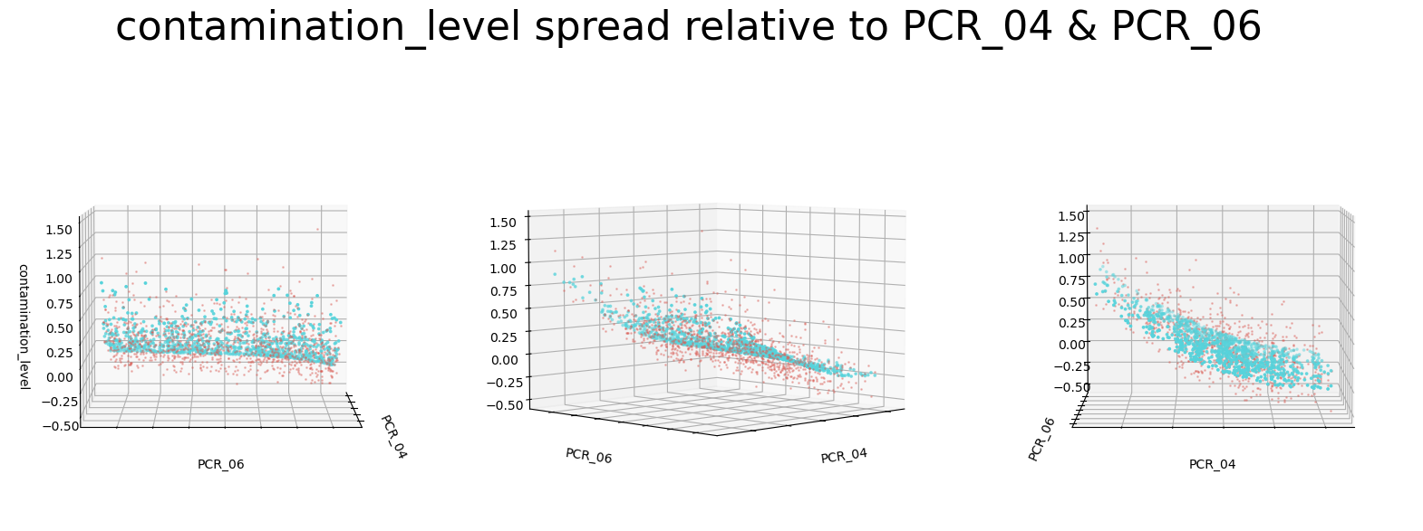
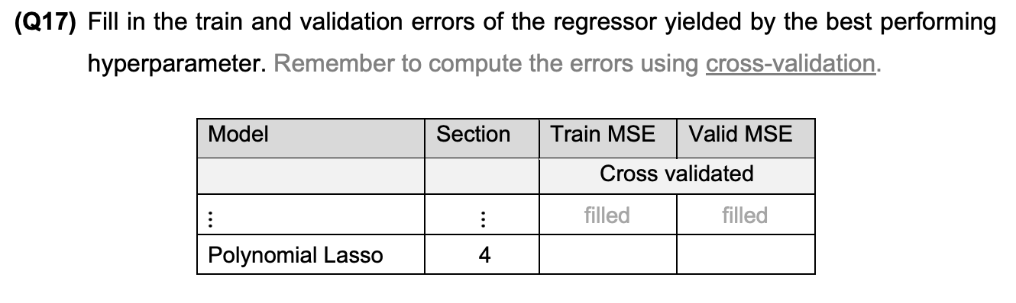
Model | Section | Train MSE | Valid MSE
 |  | Cross validation
Dummy | 2 | 0.06624823283856855 | 0.06655387736460414
Linear | 2 | 0.02247694080209269 | 0.023206892546040265
Lasso Linear | 3 | 0.022487430212685115 | 0.02313150258151016
Polynomial Lasso | 4 | 0.01708488188749001 | 0.01841226323567999

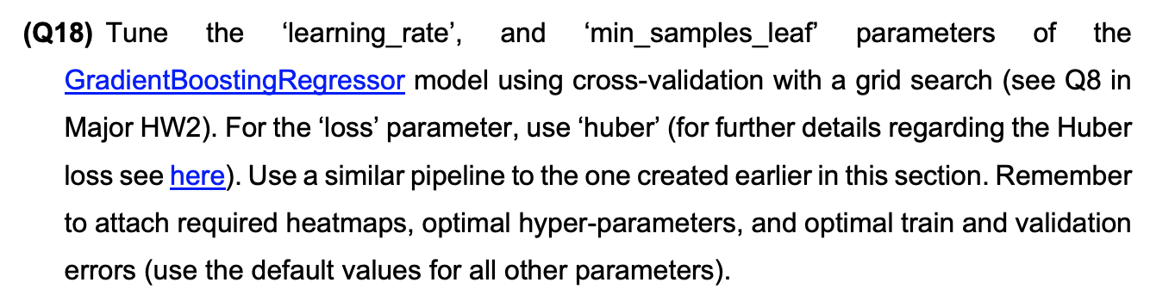
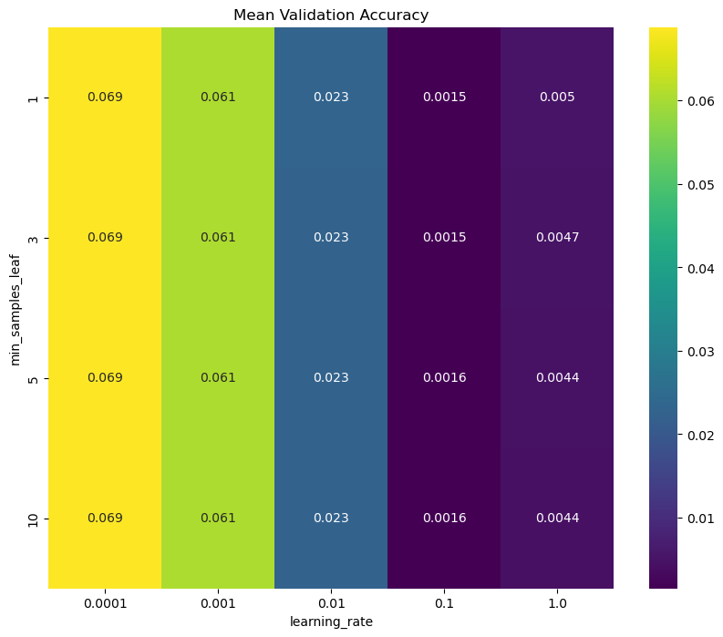

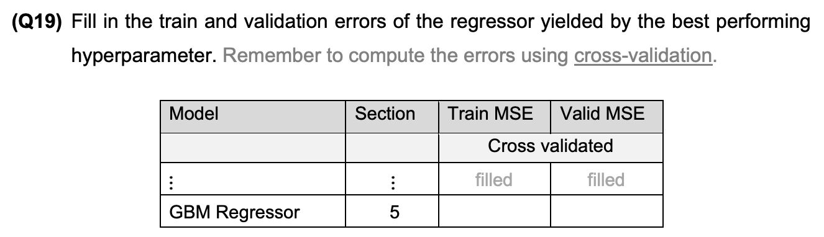
Model | Section | Train MSE | Valid MSE
 |  | Cross validation
Dummy | 2 | 0.06624823283856855 | 0.06655387736460414
Linear | 2 | 0.02247694080209269 | 0.023206892546040265
Lasso Linear | 3 | 0.022487430212685115 | 0.02313150258151016
Polynomial Lasso | 4 | 0.01708488188749001 | 0.01841226323567999
GBM Regressor | 5 | 0.0015133026206487735 | 0.0010523804993928887

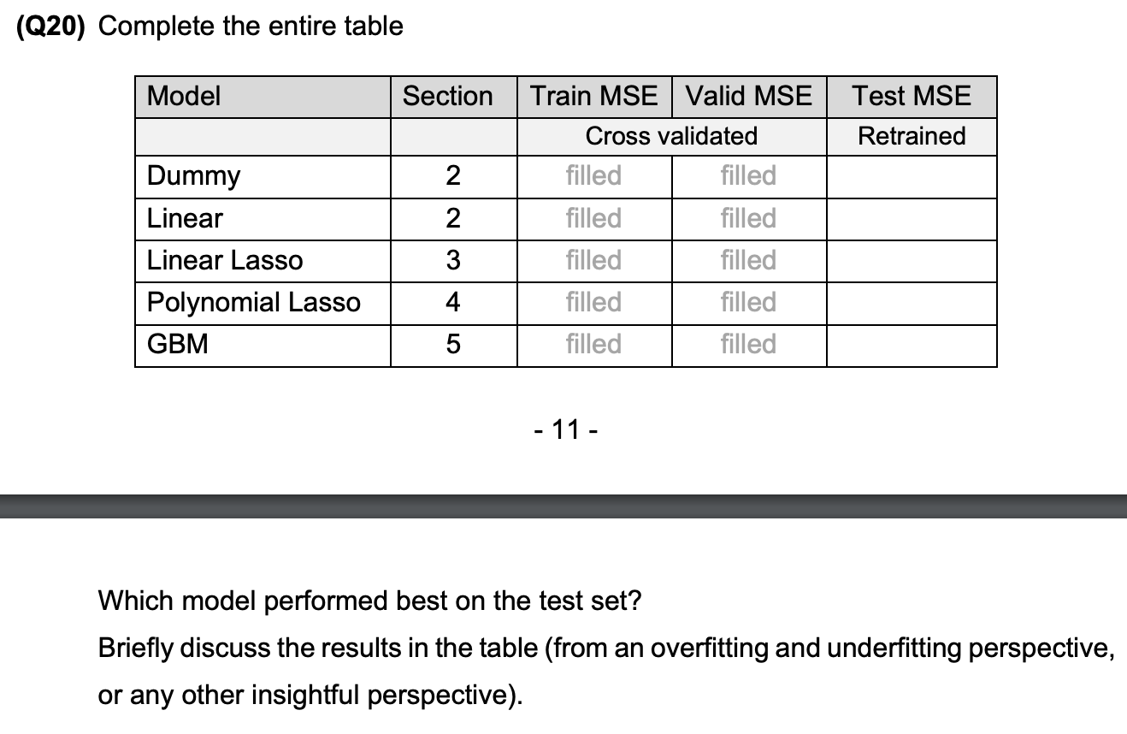
Model | Section | Train MSE | Valid MSE | Test MSE
 |  | Cross validation |  | Retrained
Dummy | 2 | 0.06624823283856855 | 0.06655387736460414 | 0.07060
Linear | 2 | 0.02247694080209269 | 0.023206892546040265 | 0.02575
Lasso Linear | 3 | 0.022487430212685115 | 0.02313150258151016 | 0.02561
Polynomial Lasso | 4 | 0.01708488188749001 | 0.01841226323567999 | 0.02779
GBM Regressor | 5 | 0.0015133026206487735 | 0.0010523804993928887 | 0.00099

- The model that performed best on the test set is the GBM Regressor model with loss of 0.00099.
- The Dummy model has the worst performance of all the 5 models. It underfits the data, because it is too simple to capture the underlying data patterns.
- Both Lasso Linear and Linear models show similar performance in training and validation. They don’t seem to have directed signs of overfitting or underfitting. Since training and validation accuracies are similar and not bad.
- The Polinomial Regressor model has lower Train and Valid MSE, than the 2 previous models. However, the ‘Test MSE’ is higher than the Linear and Lasso models, so it can mean that the model may be overfitting the training data.
- The GBM Regressor is the best of the 5 models, in the Train, Valid and Test MSE’s. It means that this model is good and it success to generalizes very well to new data, by capturing the patterns of the training data. That is since all train ,validation and test accuracies are good and similar.

